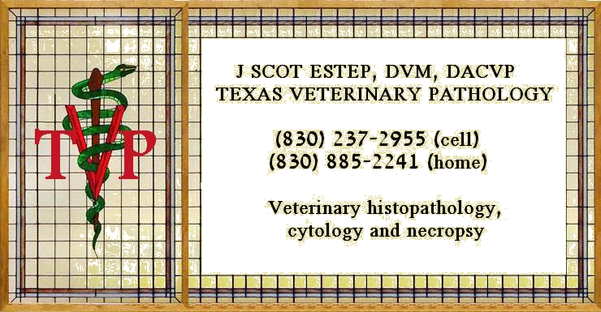
TEXAS VETERINARY PATHOLOGY LLC

J SCOT ESTEP DVM DACVP SCOT@TEXASVETPATH.COM
(830) 237-2955

JERRY R COWART DVM DACVP JERRY@TEXASVETPATH.COM
(830) 221-6846

MICHELLE THOMPSON DVM DACVP MICHELLE@TEXASVETPATH.COM

ERIC LOMBARDINI VMD MS PhD DACVPERIC@TEXASVETPATH.COM

BRIAN SMITH DVM DACVP BRIAN@TEXASVETPATH.COM

EMILY CORBIN. DVM, DACVP EMILY@TEXASVETPATH.COM

YVONNE SCHULMAN DVM, DACVP YVONNE@TEXASVETPATH.COM

Fast, personal and reliable Veterinary Pathology Consultation
TexasVetPath.com

Biopsy or necropsy sample (3-6 day turn around): $95 (Courier or FedEx pickup and shipping included) ($40.00 for each additional site, multiple biopsies of skin or small intestine for derm or GI disease considered one site)

Cytology: $95 shipping/courier included. Standard turnaround 24-48 hour for all samples once they arrive at the lab. Rush cytology, same day report, additional $40, for calls prior to 11:00 or delivered to the lab by 2:00. Please coordinate Rush cases with pathologist.

San Antonio region Full Necropsy and Histology (performed in your clinic, you provide space and disposal): $550.00 (gross only $400) call for trip charge outside San Antonio Region
Night or weekend necropsy: Additional $150.00

Contact Dr of your choice any time for questions or consultation.
Contact (830) 237-2955 for shipping labels and supplies, (210) 646-0890 for courier pickup in San Antonio region, if you have FedEx labels call (800) 463-3339 (FedEx Customer Service) for pickup or mail/ship samples and submission form to:
TVP C/O Precision Pathology, Accessioning
3300 Nacogdoches, suite 108
San Antonio, Texas 78217

Email for submission form Scot@TexasVetPath.com , Jerry@TexasVetPath.com or Terry@TexasVetPath.com

